**HAWAII FARMERS’ MARKET**

**Create a user-friendly web app to find Hawaii’s Farmers' Markets**.

**GOAL: Increase attendance and sales at Hawaii’s Farmers’ Markets that support our local growers and producers.**

**FEATURES ENVISIONED**

**Farmers’ Market Organizers**

* Ability to enter/update market information including but not limited to name, description, location, dates, times, website and contact name, email and phone number. Include on-line provisioning for setting/resetting password to access only their record.
* Ability enter list of vendors by type (i.e. plants, food, produce, etc.) and products.
* Ability to post photos.
* Ability to post “What’s happening this week” or “Special Events” by date.

** General Public**

* Ability for user to search by various criteria (i.e. by day, island, zip code, vendor, product, etc.) on their mobile device or pc.
* Ability to display “What’s happening this week” or “Special Events” (by date range, island, etc.)
* Ability to click and link to farmers’ market website if available
* Ability to generate maps based on data where user can click on a location for more information.
* Ability for users to make comments (similar to Yelp) – great way to engage the public and give feedback to organizers.
* Ability for users to rate the farmers’ market (✰✰✰✰✰)

 **Authorized State Market Development Staff**

* Ability delete market records and/or user postings if necessary.
* Access email on website: HDOA.MD@hawaii.gov

**Hawaii Department of Agriculture Contacts**

Project Manager: Sharon Hurd Phone: 973-9465 Email: [Sharon.K.Hurd@hawaii.gov](mailto:Sharon.K.Hurd@hawaii.gov)  
Project Member: Helene Okamura Phone: 973-9490 Email: [Helene.M.Okamura@hawaii.gov](mailto:Helene.M.Okamura@hawaii.gov)

**FIELDS FOR FARMER’S MARKET** (*fields required to be entered by organizer)

* Farmers Market Name*
* Day(s) of week* (Monday, Tuesday, Wednesday, Thursday, Friday, Saturday, Sunday)
* Start and end time*
* Street Address*
* City*
* Zip code*
* Island*
* Additional Location information
* Website
* Organizer Contact Name*
* Organizer Phone Number*
* Organizer Email*
* Organizer login name*
* Organizer password*
* Date modified (mm/dd/ccyy)

**FIELDS FOR VENDOR INFORMATION**

* Vendor name
* Products (i.e. produce, coffee, plants, etc.)

**EVENTS INFORMATION**

* Farmers Market Name
* Date(s) of event (mm/dd/ccyy)
* Event description

Current website: <http://hdoa.hawaii.gov/add/md/farmers-market-listings/>

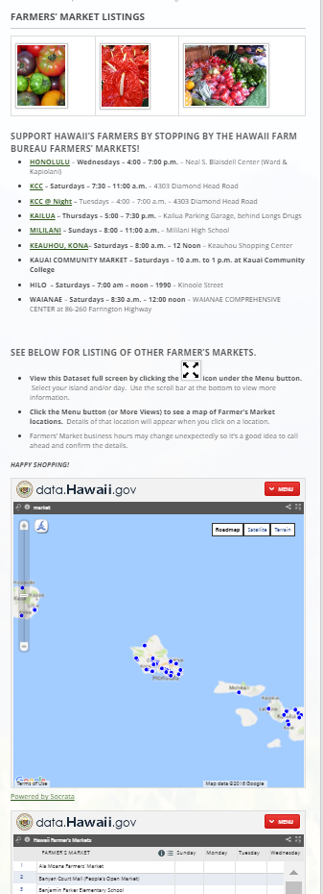

Sample screen print of existing data available on data.hawaii.gov (downloadable) or sample dataset available on github.

* 